Name _________________________ Date _____________
Period ________ Science

Identifying the Controls and Variables

1. Patrick notices that his rock is covered in a strange green slime. His friend Sponge Bob tells him that clam juice will get rid of the green slime. Patrick decides to check this out by spraying half of the rock with clam juice. He sprays the other half with water. After 3 days of “treatment” there is no change in the appearance of the green slime on either side.
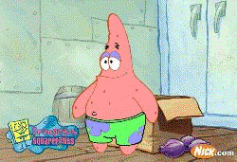

- Identify the control group: ______________________________________________

- Identify the variable: ________________________________________

- What should Patrick’s conclusion be? ____________________________________
_____________________________________________________________________

2. Mr. Krabs thinks that adding a special sauce to his Krabby Patties will make the customers want to buy more Krabby Patties. He tells Sponge Bob to make 2 groups of patties: 50 with special sauce and 50 original. Mr. Krabs instructs Squidward to serve the special sauce patties to half of the restaurant and the original patties to the other half. He also tells Squidward to keep track of which customers ordered a second Krabby Pattie. After all the patties had been served 37 customers that ate the special sauce ordered a second Krabby Pattie. Only 15 customers that ate the original ordered a second Krabby Pattie.
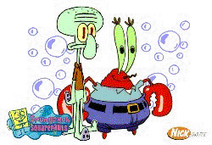

- Identify the control group: ______________________________________________

- Identify the variable: ________________________________________

- What should Mr. Krabs conclusion be? ___________________________________
_____________________________________________________________________

- How could this experiment be improved? __________________________________
_____________________________________________________________________
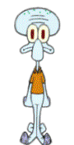
3. Squidward has been playing his clarinet a lot lately and notices that he gets a headache after all this playing. He heard an advertisement for a new headache medicine that will relieve his headache 50% faster than his old medicine. He decides to give it a try. After playing his clarinet and getting a headache Squidward took his usual headache medicine. He timed how long it took until he felt relief – 30 minutes. The next headache Squidward got after playing the clarinet he took the new medicine. He noticed relief in only 15 minutes.

- Identify the control group: ______________________________________________

- Identify the variable: ________________________________________

- Explain whether the data supports the advertisement claims about its product: _____
______________________________________________________________________

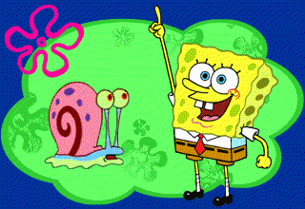
4. Sponge Bob thinks that Gary snores too much and it keeps him awake at night. He wonders if Gary’s sleeping position has anything to do with how much Gary snores. He tells Gary about his idea and Gary agrees to try sleeping in a different position. On the first night Gary sleeps in his usual horizontal position. Sponge Bob times how many minutes Gary snores. On the second night Gary sleeps vertically – stuck to the side of Sponge Bob’s bed. Sponge Bob times how long he snores. On both nights Gary snored for 3 hours and 12 minutes.

- Identify the control group: ______________________________________________

- Identify the variable: ________________________________________

- Does the sleeping position have anything to do with the snoring? _______________
______________________________________________________________________

- How could this experiment be improved? _________________________________
_____________________________________________________________________


Sandy is working on a science project. Her task is to answer the question: “Does the Krabby Pattie always land cheese side down when you drop it?” Mr. Krabs is willing to sell her Krabby Patties at half price for her experiment.

- Describe how Sandy would perform the experiment.

- Identify the control group: ______________________________________________

- Identify the variable: ________________________________________

